**Wingham Anglicans**

**Christmas Services @ St Matthews**

7 Bent St Wingham

Christmas Eve

5.30pm Faith & Fellowship @ St Matthews.

10.15pm BYO drinks and nibbles

11.00pm Holy Communion

Christmas Day

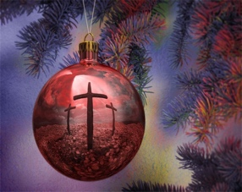10.00am Holy Communion

For More information Contact

Brian Ford 0481099640